Year Three Urology Workbook

University of Leicester Medical School

Updated July 2026

  - Contributors
Dr Anika Badrinath Rao
Miss Pravisha Ravindra
Mr Daniel Couch
Professor David Bowrey

Investigation normal ranges:

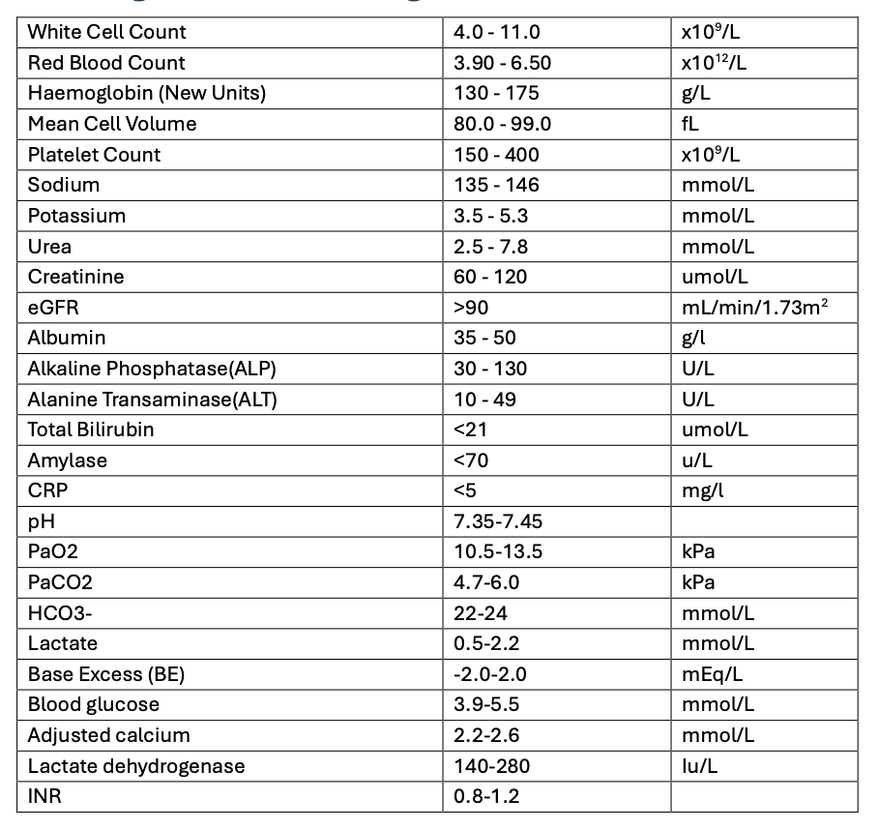

Case 1
Michael, a 74-year-old man, presents to his GP with multiple episodes of painless haematuria over the last few weeks, which are now becoming more frequent. He denies any other urinary symptoms, or unintentional weight loss.
He has a past medical history of hypertension for which he takes amlodipine 5 mg once daily.
His observations are temperature 36.7°C, heart rate 83 bpm, blood pressure 130/80 mmHg, respiratory rate 20/min, oxygen saturations 98% on air.
Abdominal examination and digital rectal examination are unremarkable.

a) Define visible haematuria and non-visible haematuria.

b) State four possible causes of haematuria in this patient, including two benign and two malignant causes.

c) State 4 further questions to ask on focussed history to exclude differential diagnoses, explaining your reasoning.

The GP performs a urine dipstick.
Urinalysis:
Blood positive
Protein negative
Nitrites negative
Leucocytes negative
Further history reveals that Michael has smoked for 50 years and is retired but previously worked in rubber manufacturing. He has no significant family history. The GP is concerned about an underlying bladder malignancy and refers him via a 2-week-wait referral to a one-stop haematuria clinic.
d) State four risk factors associated with an increased risk of bladder cancer.

e) State two investigations that should be performed at haematuria clinic, explaining the purpose of each investigation.

Investigations reveal a suspicious bladder lesion. Michael is listed for a Transurethral Resection of Bladder Tumour (TURBT) scheduled to occur in 4 weeks time.
f) What is the purpose of a TURBT?

One week prior to having his TURBT, Michael presents to the Surgical Assessment Unit (SAU) with increasing suprapubic pain and inability to pass urine for the last eight hours. He reports passing blood in his urine with some blood clots earlier today. His observations are currently stable.
Abdominal examination reveals suprapubic tenderness and a palpable bladder.
A bladder scan is performed which reveals 680 mL.
g) What is the most likely diagnosis and why has this occurred?

The clerking doctor decides to insert a 3-way catheter.
h) What is the purpose of using a 3-way

i) Label the parts of 3-way catheter below.
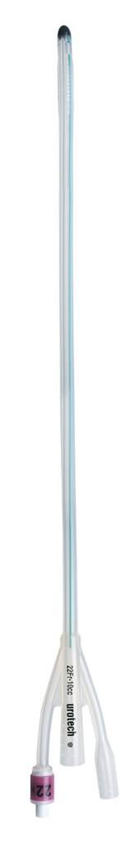

j) What catheter size would you choose and why?

A 3-way catheter is inserted successfully and irrigation begins. The catheter drains heavily blood-stained urine containing several blood clots. Michael's pain improves significantly.
k) What essential information must be documented in the patient notes following catheterisation?

Approximately one hour later, the nursing staff ask you to review Michael again as he is complaining of increasing suprapubic pain and the catheter is bypassing. His observations remain stable. Abdominal examination reveals suprapubic fullness. There is minimal urine in the catheter bag and there are no obvious kinks in the catheter tubing. The nurse has stopped irrigation and performed a repeat bladder scan, which shows 450 mL. She suggests that Michael may require a manual bladder washout.
l) Explain how a manual bladder washout is performed.

Michael’s catheter begins to drain after a bladder washout. His procedure is expedited and he undergoes a TURBT. Histology confirms high-grade urothelial carcinoma and is staged as pT2.
n) What does a stage pT2 indicate in bladder cancer?

Following discussion at the urology-oncology MDT, Michael is offered a radical cystectomy.
o) What is involved in a radical cystectomy?

p) What urinary diversion options may be considered for Michael?

Case 2
Peter, a 64-year-old man, presents to his GP after noticing a swelling on the left side of his scrotum 6 weeks ago. The swelling causes a mild dragging discomfort and is more noticeable when standing.
He denies visible haematuria, flank pain, reduced appetite or unintentional weight loss.
His past medical history includes hypertension. His BMI is 32 kg/m². He has smoked 20 cigarettes per day since the age of 29.
Examination reveals a soft, non-tender swelling above the left testis which feels like a “bag of worms”. It becomes more prominent on standing and does not disappear when he lies flat. Both testes are palpable and unremarkable.
You suspect a varicocele.
a) Are varicoceles more likely to present o the right or left side? Explain your reasoning.

The GP arranges an urgent ultrasound KUB which shows a large mass arising from the left kidney, concerning for renal cell carcinoma.
c) State two mechanisms by which a renal cell carcinoma can cause a varicocele.

f) State three risk factors for renal cell carcinoma present in Peter’s history and three further risk factors.

g) Aside from a varicocele, state four other ways renal cell carcinomas can present?

Peter is referred to Urology. Pre and post contrast-enhanced CT of the chest, abdomen and pelvis shows an 8.2 cm solid mass arising from the left kidney, compressing the left renal vein. There is no lymph node involvement or distant metastatic disease (T2a N0 M0).

Laboratory blood tests are performed and reported as follows:
White cell count | 8.6 ×10⁹/L
Haemoglobin | 146 g/L
Platelets | 310 ×10⁹/L
C-reactive protein | 15 mg/L
Sodium | 139 mmol/L
Potassium | 4.3 mmol/L
Urea | 6.8 mmol/L
Creatinine | 91 µmol/L
Corrected calcium | 2.78 mmol/L
Alanine transaminase | 31 U/L
Alkaline phosphatase | 96 U/L
Bilirubin | 12 µmol/L
Albumin | 40 g/L
l) Define a paraneoplastic syndrome.

m) What paraneoplastic syndrome is suggested by Peter’s blood results and what is the likely underlying mechanism causing this?

n) State two other paraneoplastic syndromes associated with renal cell carcinoma and explain the underlying mechanism.

Peter’s case is discussed at the uro-oncology multidisciplinary team meeting. The tumour is considered suitable for surgical treatment.
o) What is the most appropriate treatment for Peter’s renal tumour and what does this procedure involve?

p)State 3 potential management options for metastatic renal cell carcinoma.

Case 3
George, a 78-year-old man, presents to the Emergency Department as he has not passed urine for approximately 18 hours. Over the previous few days, he has only been passing small amounts of urine. He reports increasing nocturia and a progressively weaker urinary stream over the last 6 months despite taking tamsulosin.
He has been feeling increasingly lethargic and generally unwell, with nausea and a reduced appetite. He has no suprapubic pain but reports that his lower abdomen appears more bloated than normal. He denies dysuria, visible haematuria, fever or loin pain.
His past medical history includes benign prostatic hyperplasia and hypertension. His regular medications are tamsulosin 400 micrograms once daily and ramipril 5 mg once daily. He has no known drug allergies.
His observations are Temperature 36.5°C, Heart rate 72 bpm, Blood pressure 152/94 mmHg, Respiratory rate 22 breaths per minute, Oxygen saturations 98% on air.
He is alert and orientated. Abdominal examination reveals a non-tender palpable bladder. Cardiorespiratory examination is unremarkable.
A bladder scan is performed which shows approximately 1,300 mL.

Initial blood tests are reported as follows:
White cell count | 8.9 ×10⁹/L
Haemoglobin | 132 g/L
Platelets | 276 ×10⁹/L
C-reactive protein | 5 mg/L
Sodium | 139 mmol/L
Potassium | 5.9 mmol/L
Urea | 24 mmol/L
Creatinine | 190 µmol/L (baseline 92 µmol/L)
Venous blood gas results are reported as follows:
pH | 7.32
pCO₂ | 5.0 kPa
pO₂ | 5.2 kPa
Bicarbonate | 19 mmol/L
Base excess | −6 mmol/L
Lactate | 1.3 mmol/L
Glucose | 6.4 mmol/L
An urgent ultrasound KUB is performed and is reported as follows:
There is moderate bilateral hydronephrosis. No renal or ureteric calculus is identified.

a) What is the most likely diagnosis, and what is the most likely underlying cause?

b) State three abnormalities evident on the lab blood tests and blood gas. Why have these occurred?

c) Outline two initial management steps you would take in the Emergency Department and for each state your reasoning.

d) Why should an ECG be performed on the basis of the electrolyte results?

e) State 5 ECG changes seen with hyperkalaemia.

d) How would your management change if George’s potassium were 6.8 mmol/L with ECG changes?

Catheterisation with a two-way Foley catheter is unsuccessful. The ED registrar suggests that a Tiemanns catheter may help.
e) What is a Tiemann catheter, and why might it be useful?

A Tiemann catheter is successfully inserted and drains 1,450 mL of clear urine. George is admitted under Urology. The catheter is left on free drainage, and an hourly fluid balance chart is commenced.
Twelve hours later, the nurse tells you that George feels dizzy and light-headed when standing. His fluid balance chart shows that he has passed 4,400 mL of urine over the previous 12 hours. He is almost finished receiving 1 litre of intravenous sodium chloride 0.9%.
His observations are temperature 36.7°C, Heart rate 106 bpm, Blood pressure 110/62 mmHg, Respiratory rate 18 breaths per minute, Oxygen saturations 98% on air.
Repeat blood tests show:
Test | Result
White cell count | 9.2 ×10⁹/L
Haemoglobin | 138 g/L
Platelets | 284 ×10⁹/L
C-reactive protein | 6 mg/L
Sodium | 145 mmol/L
Potassium | 4.3 mmol/L
Chloride | 108 mmol/L
Urea | 18 mmol/L
Creatinine | 145 µmol/L
f) What complication has developed and explain why this complication has occurred?

h) How would you manage this complication?

Over the next three days, George’s urine output settles and his kidney function return to baseline.
The Urology team begin discharge planning.
i) Why is a trial without catheter not appropriate in this case?

George is discharged and reviewed in the Urology clinic four weeks later. The team discusses definitive treatment for his bladder outlet obstruction.
j) What management options could be discussed with George, both surgical and non-surgical?

Case 4

Jacob, a 47-year-old man presents to the Emergency Department (ED) with a 3 hour history of intermittent left flank pain radiating to the groin. He has vomited once but denies any dysuria, urinary frequency or haematuria. He has a past medical history of hypertension and hypercholesterolaemia for which he takes ramipril 5mg OD and atorvastatin 10mg OD.
His observations are temperature 37.8°C, heart rate 98 bpm, blood pressure 130/78 mmHg, respiratory rate 18/min, oxygen saturations 100% on air. On examination he is restless and appears in significant pain. Abdominal examination reveals mild left flank tenderness but is otherwise unremarkable.
Ureteric colic is suspected.
a) State four additional differential diagnoses.

Bloods are taken and urinalysis is performed in ED.
White cell count | 12.6 ×10⁹/L
Haemoglobin | 136 g/L
Platelets | 284×10⁹/L
C-reactive protein | 18 mg/L
Sodium | 138 mmol/L
Potassium | 4.4 mmol/L
Urea | 7.2 mmol/L
Creatinine | 80 µmol/L
eGFR | >90 mL/min/1.73 m²
Amylase | 72 U/L

Urinalysis:
Bld positive
Pro negative
Nitrites negative
Leu negative

b) Interpret the above investigations, commenting on any abnormalities. Do these confirm the diagnosis?

c) What is the gold standard imaging for suspected ureteric colic and why? (be specific).

d) Jacob is in pain. Prescribe 3 analgesic medications (medicine, dose, route, frequency).

e) Imaging returns and can be seen below. State two abnormalities that can be seen on this scan.

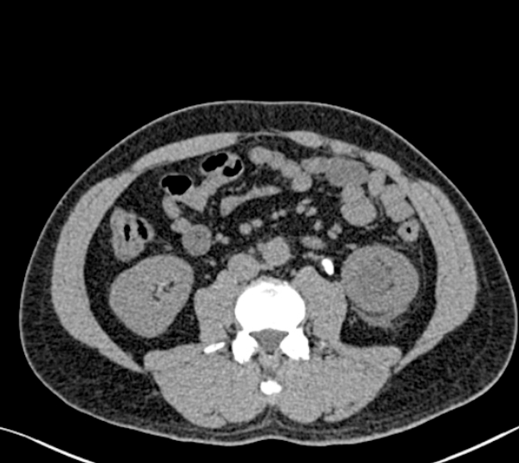
Image courtesy of radiopedia: Case study, Radiopaedia.org (Accessed on 14 Jul 2026) https://doi.org/10.53347/rID-23323.
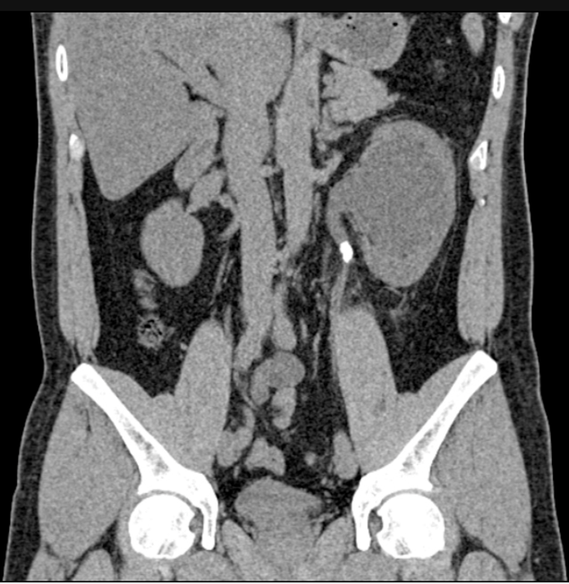

Jacob is admitted to the urology ward for ongoing management. Overnight the nurse bleeps you stating Jacobs NEWS2 score has risen from 2 to 6. She requests an urgent review. On assessment Jacob appears unwell and is complaining of worsening left flank pain. Observations are temperature 38.4°C, pulse 112/minute, blood pressure 104/68 mmHg, oxygen saturations 98% on air, and respiratory rate 24/minute. Capillary refill time is 2 seconds. Abdominal examination reveals moderate flank tenderness but is otherwise unremarkable.

Repeat bloods are taken and are reported as follows:
White cell count | 18.4 × 10⁹/L
Haemoglobin | 134 g/L
Platelets | 276 × 10⁹/L
C-reactive protein | 165 mg/L
Sodium | 135 mmol/L
Potassium | 4.8 mmol/L
Urea | 10.6 mmol/L
Creatinine | 110 µmol/L

f) Review the blood investigations. What is the most likely diagnosis? Explain your reasoning.

g) State two urgent urological procedures that could be used to manage Jacob’s condition. Briefly explain what each involves.

Jacobs' condition begins to improve over the next few days. The urology team begins to plan definitive management.
h) State two definitive procedures to manage Jacobs diagnosis. Briefly describe how each is performed.

Case 5
Amira is a 34-year-old woman, who presents to the emergency department with sudden onset severe right loin to groin pain. She denies fevers, urinary symptoms or changes in bowel habit.
She has no significant past medical history.
Observations: Temperature 36.5, heart rate 72 bpm, blood pressure 110/80 mmHg, respiratory rate 16/min, oxygen saturations 100% on air.

She has been given pain relief, and her pain is currently well controlled. Abdominal examination is unremarkable.
a) State six differential diagnoses for Amira’s presentation.
b) What further questions would you like to ask Amira on focussed history?

c) State two bedside tests and four blood tests you would request. Give your reasoning for each.

Bloods test and urinalysis are unremarkable. A urine pregnancy test is negative.
Amira has a non-contrast CT KUB which confirms a right 3mm distal ureteric stone, with no hydronephrosis or fat stranding. You discuss this with your Urology Registrar who advises that the patient can be discharged and reviewed in stone clinic in 4 week’s time.

d) What are some common urinary stone types?

e) State four predisposing factors to stone formation.

f) What investigation can be considered to check stone clearance at follow up if the stone is radio-opaque?

You have informed Amira of the diagnosis and explained that the stone will likely pass on its own.

g) What medications will you provide Amira prior to discharge?

h) What safety netting advice and stone prevention advice will you provide Amira on discharge?

Case 6
Sandra, a 66-year-old woman, sees her GP with a two-day history of dysuria and increased urinary frequency. She has a past medical history of CKD stage 3a, with a baseline eGFR of 48 mL/min/1.73 m and type 2 diabetes mellitus. Her regular medications include metformin 500mg twice daily and ramipril 2.5 mg once daily. She has no known drug allergies.
Her observations are temperature 36.8°C, heart rate 86 bpm, blood pressure 132/76 mmHg, respiratory rate 16/min, oxygen saturations 98% on air. Abdominal examination reveals mild suprapubic tenderness but is otherwise soft and non-tender.
Urinalysis:
Bld negative
Pro negative
Leu ++
Nitrites +
The GP suspects she has a lower urinary tract infection (UTI).
a) State 2 risk factors for UTI in Sandra’s history and 2 other risk factors for UTI.

b) What further questions would you like to ask Sandra to exclude an upper urinary tract infection?

The GP diagnoses Sandra with a lower UTI.
c) Suggest an appropriate antibiotic, including the dose and treatment duration (Use NICE CKS / BNF / UHL trust guidelines).

Two days later, Sandra presents to the Emergency Department with fever, rigors, right-sided loin pain and vomiting. Her observations are temperature 38.9°C, heart rate 118 bpm, blood pressure 96/58 mmHg, respiratory rate 22/min, oxygen saturations 98% on air.
She is alert but appears unwell. Abdominal examination reveals right renal angle tenderness. Cardiorespiratory examination is unremarkable.
Bloods are taken and are reported as below:
White cell count | 18.4 ×10⁹/L
Haemoglobin | 132 g/L
Platelets | 356 ×10⁹/L
C-reactive protein | 210 mg/L
Sodium | 135 mmol/L
Potassium | 4.7 mmol/L
Urea | 13.8 mmol/L
Creatinine | 178 µmol/L (baseline 120)
eGFR | 30 mL/min/1.73 m² (baseline 48)
Venous blood gas is reported as below:
pH | 7.34
Bicarbonate | 22 mmol/L
Lactate | 3.8 mmol/L
Glucose | 7.8 mmol/L
d) What is your working diagnosis (be specific)?

e) Interpret the bloods and venous blood gas.

f) State three further investigations that should be performed and why.

g) State four initial management steps you would take in the emergency department.

h) What modifications would you make to her regular medications and why?

US KUB is performed and is reported as follows:
No evidence of urinary tract obstruction or renal/perinephric collection.
Urine culture:
ESBL-producing Escherichia coli.
Sensitivity results:
Trimethoprim: resistant
Nitrofurantoin: resistant
Co-amoxiclav: resistant
Cefalexin: resistant
Ciprofloxacin: resistant
Gentamicin: sensitive
Meropenem: sensitive

i)What is extended-spectrum beta-lactamase (ESBL) producing Escherichia coli and what is the clinical significance of this?

j) State 3 precautions should be taken on the ward for infection control purposes?

Following discussion with microbiology, Sandra is treated with intravenous meropenem. Her dose is adjusted for her renal function, and her clinical condition and renal function improve.

Case 7
Daniel, a 24-year-old man, presents to the surgical assessment unit (SAU) with pain and swelling of his right testicle. The pain started gradually 3 days ago and has become progressively worse. He also reports dysuria and a small amount of urethral discharge.
Daniel has recently started a new relationship and reports having unprotected sexual intercourse.
His observations are temperature 37.5°C, Heart rate 96 beats per minute, Blood pressure 128/76 mmHg, respiratory rate 16 breaths per minute, oxygen saturations 99% on air.
Examination reveals a red and swollen right hemiscrotum. The right epididymis and testis are very tender to touch. Prehn’s sign is positive and the cremasteric reflex is present.
Epididymo-orchitis is suspected.

a) State four clinical features that support epididymo-orchitis rather than testicular torsion.

c) State two common bacterial causes of epididymo-orchitis in younger males.

d) State two common bacterial causes of epididymo-orchitis in older males? And State 3 risk factors for developing epididymo-orchitis in this age group.

d) What bloods and bedside tests should be requested for Daniel?

e) When may ultrasound of the testes be considered?

Treatment is commenced while the results are awaited.
f) What empirical antibiotic treatment should Daniel receive?

Daniel is discharged with a course of oral antibiotics.
g) What further advice should be provided to Daniel prior to discharge?

Case 8

Dina is 45-year-old woman who presents to her GP with a 6-month history of incontinence. She works as a teacher and reports several embarrassing episodes of involuntary leakage at work. She describes how whilst teaching she will suddenly feel a need to pass urine, and on some occasions has not been able to get the bathroom in time. She has a past medical history of hypertension, pre-diabetes and is perimenopausal. She has had two children, both by vaginal delivery. She has a BMI of 28 and is a non-smoker.

- How would Dina’s urinary incontinence be categorised?

- What questions would need to be included in the history? What differential diagnoses need to be excluded?

- Which initial conservative management strategies are the GP likely to recommend?

- As she is perimenopausal, what could the GP consider starting with a view to improve her overactive bladder symptoms?

Following 6 weeks of initial management Dina returns to her GP reporting minimal improvement in her symptoms. Her GP considers pharmacotherapy.

- What is the first line class of therapeutic agents that the NICE guidelines recommend for the medical management of overactive bladder? What side effects should Dina be counselled on?

- What is the second line class of therapeutic agents that the NICE guidelines recommend for the medical management of overactive bladder? What side effects should Dina be counselled on?
Following several months of medical management, Dina is still struggling with urinary incontinence. Her GP agrees to refer her to a specialist.

- What further treatment options might be offered in secondary care?

Case 9

Fiona is a 63-year-old who has been seeing nurse specialists for supervised pelvic floor muscle training for 6 months to manage her stress incontinence. Despite adhering to her exercise regime diligently. She has been referred to see a urogynaecologist.

- What surgical treatment could be suggested as she has failed conservative measures?

- If she did not wish to pursue surgery, what medication could be prescribed to try and help manage her stress incontinence?

Case 10

You are the FY1 working in ED. Muhammed, a 13-year-old boy presents with his mother complaining of severe pain in his right testicle. The pain started suddenly 1 hour ago and has vomited once.

His observations are stable.
Examination reveals a high riding right testicle that is very tender and swollen. The cremasteric reflex is absent on the right, and present on the left.

You suspect testicular torsion.
a) State four alternative differential diagnoses to consider.

b) What further questions on ficussed history should be asked to exclude alternative differentials?

c) State three risk factors for developing testicular torsion.

d) What is the cremasteric reflex, and what does absence of this reflex suggest?

The ED registrar refers the patient to Urology for urgent surgical exploration.
e) State three initial actions to prepare Muhammed for surgery.

Muhammed undergoes surgical exploration which confirms torsion of the right testicle. The right testis is untwisted and deemed viable.
f) Given the right testis is viable, what procedure should the urologist perform and why?

g) If the right testis were necrotic, how would this change surgical management?

Case 11

Christopher, a 22-year-old man presents to his GP after noticing a lump on his right testicle 2 weeks ago. He has no significant medical history.
On examination there is an irregular firm painless mass measuring approximately 3cm x 2cm. The mass does not transilluminate and is inseparable from testis.

The GP suspects testicular cancer.
a) State 6 alternative differential diagnoses for a testicular lump.

b) What further questions should e asked on focussed examination?

c) What referral pathway should the GP consider ?

d) What imaging should be urgently arranged in secondary care?

e) How are testicular tumours classified? Give two examples for each.

f) What tumour markers should be requested? For each tumour marker state the significance if elevated.

Imaging confirms a mass in the right testis concerning for testicular cancer.
d) What further imaging needs requesting and why?

Christopher’s case is discussed in Urology-oncology MDT. Further investigations confirm Marsden stage I (disease confined to the testes). He is offered a right inguinal orchidectomy.

e) What is the lymphatic drainage of the testes?

f) Explain why an inguinal approach is used as opposed to a scrotal approach?

Case 12
Peter, a 68-year-old man, attends his GP requesting a prostate specific antigen test (PSA). Over the past year he reports needing to get up to pass urine 3-4 times every night and states his urine stream is weaker. He denies any dysuria, visible haematuria or unintentional weight loss. He is concerned as his brother has recently been diagnosed with prostate cancer at the age of 62.
Abdomen examination reveals a soft and non-tender abdomen. Digital Rectal Examination reveals an asymmetrical prostate, with a hard, irregular nodularity in the posterior lobe.
The GP is concerned about prostate cancer.
a) State four non-modifiable risk factors associated with prostate cancer.

b) How would you counsel Peter on PSA testing?

c) Aside from prostate cancer, list six other potential causes of a raised PSA.

The GP requests a urine dipstick and blood tests which are reported as follows.
Bloods:
PSA | 11.8 ng/mL
Hb | 145 g/L
WCC | 7.4 ×10⁹/L
Creatinine | 82 µmol/L
eGFR | >90
Urine dipstick results:
Blood negative
Protein negative
Nitrites negative
Leucocytes negative

d) How should Peter’s PSA result be interpreted?

He is referred on a 2 week wait pathway and undergoes a multiparametric MRI prostate, which demonstrates a suspicious lesion in the posterior peripheral zone. The MDT recommends a Trans Perineal template biopsy of the prostate.
e) State four risks that should be explained to Peter during informed consent for a Trans Perineal template biopsy of the prostate.

Histology report confirms an adenocarcinoma of the prostate.
Gleason 7 (4 + 3) Grade Group 3

f) Explain how Gleason scoring is calculated.

g) Explain how Gleason 7 (4 + 3) differs from Gleason 7 (3 + 4).

Staging reveals T2N0M0 disease. The MDT states that Peter’s prostate cancer is intermediate risk and suggests radical treatment.

i) What radical treatment options are available for localised prostate cancer? State one complication of each treatment that you should inform peter about.

Case 13
Richard is a 71-year-old man who presents to his GP with a complaint of increased frequency over the past 6 months. He reports that he gets up 3-4 times during the night to pass urine. He has no significant past medical history and is a golfer, though he complains that he struggles to get through a game due to needing to pass urine.

- What questions should be asked to explore Richard’s symptoms further?

Further questioning reveals Richard is a current smoker with a BMI of 31. Other than one game of golf per week, he is relatively inactive.

- Other than smoking, obesity and level of physical activity, list some modifiable and non-modifiable risk factors for BPH?

Richard’s GP performs an abdominal examination - to assess for signs of a distended, tender, palpable/ percussible bladder - and an examination of the external genitalia - to identify conditions that may cause or contribute to LUTS (for example, phimosis, meatal stenosis, or penile cancer). They then perform a digital rectal examination, finding that the prostate is enlarged, but smooth, symmetrical and non-tender consistent with BPH.

- Richard is bothered by his nocturia, how can an assessment for nocturnal polyuria be performed?

- What conservative management strategies might be offered by Richard’s GP to manage his symptoms?

- Which three classes of therapeutic agents might be offered by Richard’s GP to manage his symptoms? For each class, give an example of the medication and possible side effects.

- What investigations will the GP need to perform and why?

Despite 6 months of combination treatment with two medical agents, Richard continues to have bothersome LUTS. He asks his GP to refer him to a urologist. At the clinic he undergoes urodynamics testing.

g) What is urodynamic testing?

h) Why might urodynamics be considered before surgery in Richard’s case?

i) How do video urodynamics differ from standard urodynamics?

Surgery is discussed with Richard.

- Give two surgical options for managing Richard’s BPH?

Case 14
David, a 58-year-old man, presents to his GP with difficulty achieving and maintaining an erection. The problem started gradually 9 months ago and now occurs every time he attempts sexual intercourse. He rarely experiences morning erections, but his libido is unchanged.
His past medical history includes type 2 diabetes, hypertension and depression. His regular medications are metformin, ramipril and sertraline. He smokes 15 cigarettes per day and drinks approximately 18 units of alcohol per week.
His observations are blood pressure 134/82 mmHg and heart rate 88 bpm. His BMI is 31 kg/m².
Examination of the penis and testes is unremarkable.
The GP suspect erectile dysfunction.
- State six causes of erectile dysfunction.

- What further questions would you like to ask to help identify the cause of David’s erectile dysfunction?

- i) State four features in David’s history that increase his risk of cardiovascular disease. ii) Why is cardiovascular risk assessment important in men presenting with erectile dysfunction?

- Suggest two blood tests that should be requested to assess for an underlying cause of erectile dysfunction and cardiovascular risk.

- What non-pharmacological advice should you provide David to address his cardiovascular risk?

David’s lipid profile shows a non-HDL cholesterol of 5.0 mmol/L. His early-morning total testosterone is within the normal range. He has no chest pain or breathlessness and has good exercise tolerance. He has no history of cardiovascular disease and does not take nitrate medication. His 10-year QRISK3 score is 24%. Following a discussion about the benefits and risks of treatment, David is started on atorvastatin 20 mg once daily. David would like treatment for his erectile dysfunction.

- State the first-line class of medication used to treat erectile dysfunction and give four examples.

The GP prescribes sildenafil.
- State four contraindications to prescribing sildenafil and explain your rationale.

- What potential adverse effects should you inform David about taking sildenafil? State 2 common and two rare effects.

David takes sildenafil as advised and reports that it is effective. Several weeks later, David presents to ED with a very painful erection. It started after taking sildenafil and has persisted for 5 hours despite no further sexual stimulation. The ED registrar diagnoses priapism.
- What is priapism?

- What is the difference between ischaemic and non-ischaemic priapism?

- Outline the immediate management of suspected ischaemic priapism.

UKMLA Mapping:

Case number | Presentation | Case Conditions
1 | Haematuria | Bladder cancer / clot retention
2 | Scrotal lump | Renal cell carcinoma presenting as varicocele
3 | Anuria/oliguria | High Pressure Chronic Retention
4 | Renal colic | Ureteric stone > Infected obstructed kidney
5 | Renal colic | uncomplicated ureteric stone
6 | Urological infection | Lower UTI / Pyelonephritis
7 | Urological infection | Epididymo-orchitis
8 | Urinary incontinence | Urge incontinence
9 | Urinary incontinence | stress incontinence
10 | Testicular pain | Testicular Torsion
11 | Testicular / scrotal lump | Testicular cancer
12 | prostate cancer | Prostate Cancer
13 | Obstructive uropathy | BPH
14 | Impotence and erectile dysfunction | Erectile dysfunction

Case number | Presentation | MLA mapping – Condition | MLA mapping - capabilities
1 | Haematuria | Bladder cancer | Obtains and evaluates relevant information about the patient through appropriate history and physical and/or mental health examination, formulating a prioritised list of problems and differential diagnoses  Identifies and requests relevant investigations, interprets results and ensures they are acted on appropriately in the context of the clinical situation, avoiding over-investigation, over-diagnosis and overprescription  Generates management plans in emergency and acute presentations, and manages patients perioperatively  Performs procedures safely  Uses and records information safely and effectively
2 | Scrotal lump | Renal cell carcinoma  varicocele | Obtains and evaluates relevant information about the patient through appropriate history and physical and/or mental health examination, formulating a prioritised list of problems and differential diagnoses  Identifies and requests relevant investigations, interprets results and ensures they are acted on appropriately in the context of the clinical situation, avoiding over-investigation, over-diagnosis and overprescription  Generates management plans in emergency and acute presentations, and manages patients perioperatively
3 | Anuria/oliguria | Urinary retention/ obstructive uropathy  Benign Prostatic Hyperplasia (BPH) | Obtains and evaluates relevant information about the patient through appropriate history and physical and/or mental health examination, formulating a prioritised list of problems and differential diagnoses  Identifies and requests relevant investigations, interprets results and ensures they are acted on appropriately in the context of the clinical situation, avoiding over-investigation, over-diagnosis and overprescription  Generates management plans in emergency and acute presentations, and manages patients perioperatively  Generates management plans for chronic conditions  Prescribes, reviews, communicates and monitors the effects of medicines safely and effectively  Performs procedures safely
4 | Renal colic | Urinary tract calculi | Obtains and evaluates relevant information about the patient through appropriate history and physical and/or mental health examination, formulating a prioritised list of problems and differential diagnoses  Identifies and requests relevant investigations, interprets results and ensures they are acted on appropriately in the context of the clinical situation, avoiding over-investigation, over-diagnosis and overprescription  Generates management plans in emergency and acute presentations, and manages patients perioperatively  Prescribes, reviews, communicates and monitors the effects of medicines safely and effectively  Performs procedures safely
5 | Renal colic | Urinary tract calculi | Obtains and evaluates relevant information about the patient through appropriate history and physical and/or mental health examination, formulating a prioritised list of problems and differential diagnoses  Identifies and requests relevant investigations, interprets results and ensures they are acted on appropriately in the context of the clinical situation, avoiding over-investigation, over-diagnosis and overprescription  Generates management plans in emergency and acute presentations, and manages patients perioperatively  Prescribes, reviews, communicates and monitors the effects of medicines safely and effectively
6 | Urological infection | Urinary tract infection  Pyelonephritis | Obtains and evaluates relevant information about the patient through appropriate history and physical and/or mental health examination, formulating a prioritised list of problems and differential diagnoses  Identifies and requests relevant investigations, interprets results and ensures they are acted on appropriately in the context of the clinical situation, avoiding over-investigation, over-diagnosis and overprescription  Generates management plans in emergency and acute presentations, and manages patients perioperatively  Prescribes, reviews, communicates and monitors the effects of medicines safely and effectively  Manages risk
7 | Urological infection | Epididymo-orchitis | Obtains and evaluates relevant information about the patient through appropriate history and physical and/or mental health examination, formulating a prioritised list of problems and differential diagnoses  Identifies and requests relevant investigations, interprets results and ensures they are acted on appropriately in the context of the clinical situation, avoiding over-investigation, over-diagnosis and overprescription  Generates management plans in emergency and acute presentations, and manages patients perioperatively  Prescribes, reviews, communicates and monitors the effects of medicines safely and effectively  Generates management plans to promote health and prevent disease
8 |  | Urinary incontinence | Obtains and evaluates relevant information about the patient through appropriate history and physical and/or mental health examination, formulating a prioritised list of problems and differential diagnoses  Generates management plans for chronic conditions  Generates management plans to promote health and prevent disease  Prescribes, reviews, communicates and monitors the effects of medicines safely and effectively  Communicates effectively with patients, relatives, partners, carers and other advocates
9 | Urinary incontinence | Urinary incontinence | Generates management plans for chronic conditions  Prescribes, reviews, communicates and monitors the effects of medicines safely and effectively  Generates management plans in emergency and acute presentations, and manages patients perioperatively  Communicates effectively with patients, relatives, partners, carers and other advocates
10 | Testicular pain | Testicular Torsion | Obtains and evaluates relevant information about the patient through appropriate history and physical and/or mental health examination, formulating a prioritised list of problems and differential diagnoses  Generates management plans in emergency and acute presentations, and manages patients perioperatively
11 | Testicular / scrotal lump | Testicular cancer | Obtains and evaluates relevant information about the patient through appropriate history and physical and/or mental health examination, formulating a prioritised list of problems and differential diagnoses  Identifies and requests relevant investigations, interprets results and ensures they are acted on appropriately in the context of the clinical situation, avoiding over-investigation, over-diagnosis and overprescription  Generates management plans in emergency and acute presentations, and manages patients perioperatively
12 | prostate cancer | Prostate Cancer | Obtains and evaluates relevant information about the patient through appropriate history and physical and/or mental health examination, formulating a prioritised list of problems and differential diagnoses  Identifies and requests relevant investigations, interprets results and ensures they are acted on appropriately in the context of the clinical situation, avoiding over-investigation, over-diagnosis and overprescription  Generates management plans in emergency and acute presentations, and manages patients perioperatively  Communicates effectively with patients, relatives, partners, carers and other advocates  Demonstrates understanding of patient capacity, consent and confidentiality in delivering care
13 | Obstructive uropathy | Benign prostatic hyperplasia | Obtains and evaluates relevant information about the patient through appropriate history and physical and/or mental health examination, formulating a prioritised list of problems and differential diagnoses  Identifies and requests relevant investigations, interprets results and ensures they are acted on appropriately in the context of the clinical situation, avoiding over-investigation, over-diagnosis and overprescription  Generates management plans for chronic conditions  Prescribes, reviews, communicates and monitors the effects of medicines safely and effectively  Generates management plans to promote health and prevent disease  Communicates effectively with patients, relatives, partners, carers and other advocates
14 | Impotence and erectile dysfunction | Erectile dysfunction (could not find on UKMLA content map) | Obtains and evaluates relevant information about the patient through appropriate history and physical and/or mental health examination, formulating a prioritised list of problems and differential diagnoses  Identifies and requests relevant investigations, interprets results and ensures they are acted on appropriately in the context of the clinical situation, avoiding over-investigation, over-diagnosis and overprescription  Generates management plans in emergency and acute presentations, and manages patients perioperatively  Generates management plans for chronic conditions  Generates management plans to promote health and prevent disease  Prescribes, reviews, communicates and monitors the effects of medicines safely and effectively

